**1.Entities List:-**

**Person, Account,Financial_Institution, Education_Qual, School, school_fee_payment, Gold_Arnament,Grocery_Item.**

**2. Attributes List of Each entity:-**

**a.Person:**

**AttributeList={pid,pName, Aaadhar_no,pan_no, Gender, dob, tob, lob, photo, age, contact_no, father_name, mother_name, no_of_sisters, no_of_brothers }**

**b.Account:**

**AttributList={acc_no,acc_type,debt_card,credit_card,min_bal,prin_amt,mat_amt,duration,int_rate,nominee, MI,EMD,guardian,closing_date}**

**c.Financial Institution:**

**AttributeList={ISDN,name,address,FI_Type}**

**d. School:**

**AttributeList={s_id,sName,Address,school_type}**

**e.school_fee_payment:**

**AttributeList={payment_id,payment_date,pay_amt,payment_mode,to_whom,standard}**

**f.Educational_qual:**

**AttributeList={Qual_name,YOP,clg/school,University/Board,Grade, percentage ,certificate _image }**

**g.Gold_Arnament:**

**AttributeList={item_no,item_name,quntity,DOM,AtWhommade,Total_price,is It kdm ,item _photo}**

**h.Grocessory_Item:**

**AttributeList={ item_name,qty,price,DOP,TOP,shop_name,who_purchased}**

**3. Entity Set Types:**

**Strong Entity Sets={** person, Educational_Institution, Financial_Institution, Account, School_fee_payment ,Gold_Arnament}

**Weak Entity Sets={** Educational_qual, grocery_item}

**4. Attribute Types:**

**4.1. Primary key:**



4.2**. Composite Attribute**:



4.3. **Multivalued Attribute:**

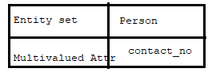

4.4.**Derived Attribute:**

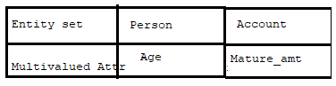

Note:- Remaining attributes are stored attributes , simple and single attributes.

**5.RelationShip Model:-**

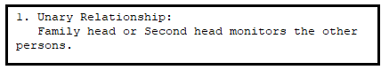

5.2. Binary Relation-ship

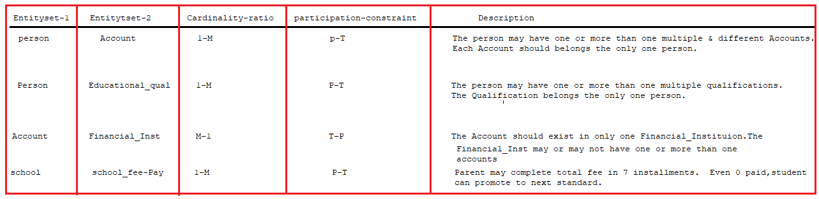

Note:- The relationship between person and Educational_qual is “**weak-Binary Relationship**”.

**6.Class-hierarchy:-**

**Super Entity set : Account**

**Attributes:** acc_no,acc_type,Doo,c_card,d_card,min_bal

**Specialization Entity sets:**

**1.FD**

**Attributes:** Prin_amt,Mat_amt,int_rate,nominee,MI,closing_date,FD_no

Participation Constraint: Total

**2.RD/SSA**

**Attributes:**SSA_no,Guardian,total_amt,closing_date.

Participation Constraint: Total